**AUSTIN BAT REFUGE BAT ADMISSION FORM**

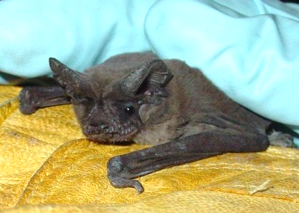**Date:________________________ Species:__________________________**

**Location Found (Address or other identifier): ____________________________________________________________________**

**____________________________________________________________________**

**Circumstances (found on ground; observed attacked by cat, etc.): ____________________________________________________________________**

**PUBLIC WAIVER**

**Bats are a rabies vector species. Rabies is an infectious viral disease that affects the nervous system of humans and other mammals. People can get rabies from the bite of an animal infected with the rabies virus (a rabid animal). Almost any wild mammal (i.e., a skunk, fox, raccoon, coyote, bat) can have rabies and transmit it to a person with a bite. It is also possible, but rare, for a person to get rabies if infectious material from a rabid animal (saliva, brain or spinal tissue) gets into a person’s eyes, nose, mouth or a wound. People cannot get rabies from having contact with bat guano (feces), blood or urine, or from touching a bat on its fur (although bats should never be handled—any wild animal might bite in self-defense if frightened). Please write on this line the following statement:** **No one has had direct contact with or been bitten by this bat.**

**Source: CDC.gov**

Na**me:__________________________________________________________________________________________**

**Address:_____________________________________________________________Apt.#_______________________**

**City/State:________________________________________________________ Zip:___________________________**

**Email:________________________________________________________ Phone:____________________________**

**By signing below, I state that all of the information above is true:**

**SIGNATURE:______________________________________________________________ DATE:__________________**

How did you hear about us? □ Web Search □ facebook □ Other Social Media □ 311 □ Wildlife Rescue □ Repeat

□ Bat Conservation International □ Texas Parks & Wildlife □ Police or Sheriff □ Other Bat Groups □ Other

**Wild animals do not carry health insurance! Austin Bat Refuge is able to provide care for bats only with assistance from you through your tax-deductible donation. We are an all-volunteer, state-permitted 501(c)3 NON-PROFIT rehabilitation organization and receive no government funding. Our costs can be under $20 for a healthy, quickly-released bat to more than $200 for a bat with a broken bone. Only with your support can Austin Bat Refuge care for the hundreds of bats we receive each year.**

**ANY DONATION AMOUNT IS APPRECIATED. Amount of Donation $________________**

Method of Payment: □ VISA □ MASTERCARD □ DISCOVER □ CASH □ CHECK

**Credit & Debit Cards & PayPal payments accepted at:** [**http://austinbatrefuge.org/donations/**](http://austinbatrefuge.org/donations/)

**Physical Exam: Male___ Female ___**

**Eyes**

**Teeth**

**Gums**

**Wings**

**Hydration**

**Emaciated?**

**Final Disposition: Released ____ Died ____ Euthanized ____ Date ________**

**NOTES: (continue on back)**